Personara Provider Cohort Workflow Guide
A practical setup and operating guide for outplacement providers, insurers, recruiters, and career transition teams.
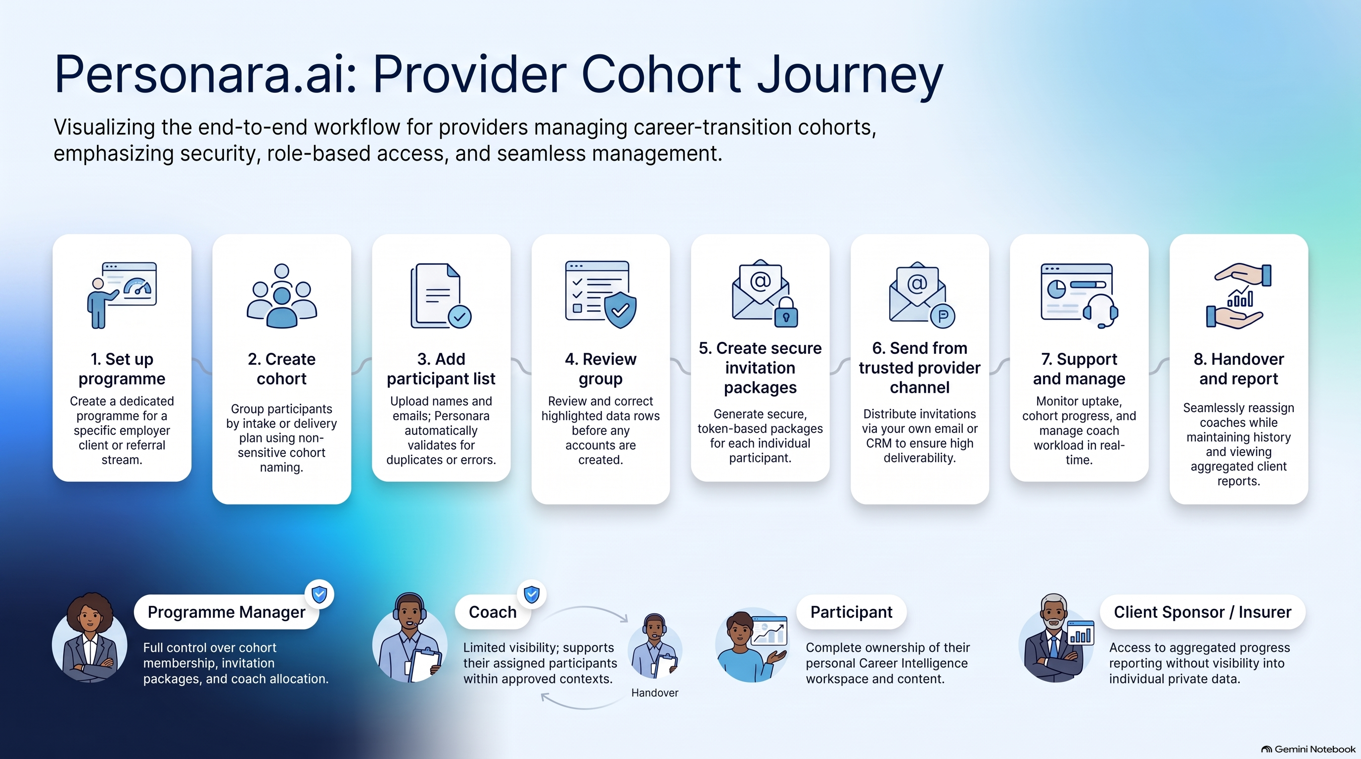
Provider cohort journey: from programme setup through support, handover, and reporting.

What this guide helps you do
Use this guide to set up a provider programme, create cohorts, add participants safely, send invitations from your own trusted channel, organise coach support, and keep a clear record of programme history. It is designed for organisations managing groups of people, not for individual candidates using their own Career Intelligence workspace.
The recommended model is simple: Personara validates participant details and creates secure invitation packages, while your organisation sends the invitations from its existing email or CRM. This reduces the chance of messages being blocked by spam or security systems and keeps your communications under your own brand and governance.

Choose your provider model
Organisation | Typical use | Who manages the cohort | Useful programme structure
Outplacement provider | Career transition support after redundancy, restructure, or change. | Programme manager and assigned coaches. | A programme per employer client, intake date, or support package.
Insurance company or rehabilitation team | Return to work, vocational rehabilitation, or career redirection. | Case manager with approved coaches or advisers. | A programme per insurer client, referral stream, or intervention period.
Recruitment or talent transition firm | Candidate redeployment, executive transition, or candidate nurture. | Recruiter or delivery lead with optional coaches. | A programme per client campaign, location, or candidate group.
Employer transition team | Internal redeployment or employer-funded career support. | HR lead or external provider team. | A programme per business unit, site, consultation round, or cohort.

The end to end workflow
- Create the provider programme. Record the provider name, programme name, optional employer client, delivery model, and any agreed follow-up date.
- Set the programme rules. Confirm who may see candidate information, who may act as a coach, and what consent or client approvals are required before access is granted.
- Create a cohort. Use one cohort for people who share a practical delivery arrangement such as the same employer client, intake window, location, or support package.
- Add the participant group. Upload or paste a Name, Email list, then review every highlighted issue before creating invitation packages.
- Send invitations from your own trusted channel. Download the secure packages and send them from your organisation email, CRM, or approved communications platform.
- Monitor uptake and support. Use the programme dashboard to see participant caseload, review needs, assigned coach, next support action, and programme status.
- Manage changes. Reassign a candidate to a new coach when needed, record the handover reason, and preserve the candidate history for continuity.
- Close and retain the record. Mark a programme or cohort complete when delivery finishes, then use its history for reporting, follow-up, renewal, and service improvement.

Workflow 1 Set up a provider programme
Start at Outplacement programmes and select Create first programme. This creates the container that holds the delivery record, cohorts, participants, coach assignments, and programme history.
Field | What to enter | Why it matters
Provider name | The organisation delivering the service. | Makes ownership clear for staff and reporting.
Provider URL slug | A short lowercase identifier using letters, numbers, and hyphens, for example northstar-careers. | A slug is simply a short safe name used inside web links. It is not a password and should not contain personal information.
Programme name | A clear delivery name, for example Northstar 2026 Career Transition Support. | Helps staff distinguish programmes in the dashboard and history.
Employer client | The client organisation if the work is employer-funded. Leave blank if it does not apply. | Separates client work without putting candidate information in the title.
Delivery model | One to one, one to many, or one to all. | Sets the intended support pattern. Individual coach assignments can still be refined later.
Follow-up date | An agreed review milestone if one exists. | Creates a prompt for programme review without forcing a date before it is agreed.

Before creating the programme, check that the person setting it up is authorised to manage the client relationship and that the programme name does not disclose sensitive personal circumstances.

Workflow 2 Create and name a cohort
A cohort is a manageable group inside a programme. The cohort should tell staff what the group has in common and what delivery plan applies to it. Create a separate cohort when the people need a different employer client, timeline, package, region, consent arrangement, or coach group.
Cohort name example | Use when | Do not use when
Northstar Auckland September intake | People start support together in Auckland in September. | You need to expose a person’s health, employment, or claim detail.
Contoso redeployment managers | The same employer client funds a manager transition group. | The group has materially different access permissions.
Insurer work readiness pilot | A defined pilot has its own service window and review point. | The name could identify an individual claimant.

- Keep cohort names descriptive, neutral, and suitable for shared dashboards and reports.
- Use a single source of truth for cohort ownership: one delivery lead should be accountable for membership and support decisions.
- Record the intended start, review, and close dates in the programme process, even if the platform does not yet require all of them.

Workflow 3 Add a group of participants
From the programme dashboard, select Invite, then Add a group of participants. You can download the CSV template or paste a two-column list with Name and Email. The system checks the list before secure invitation packages are created.
- Prepare a spreadsheet or export with exactly two columns: Name and Email. Remove duplicate rows and check that each person has agreed to receive programme information.
- Upload the CSV or paste the list. Start with a smaller group if this is your first use of the process.
- Select Review group. Correct missing names, invalid emails, or duplicate entries before continuing.
- Select Create secure invitation packages only once the group is correct. This creates the participant access packages.
- Download the packages immediately. Send each secure link through your provider email, CRM, or another approved channel. Do not send raw links through an unapproved shared spreadsheet or public chat.
- Track acceptance and support needs from the programme dashboard. Re-send only through your own approved communications process if needed.

Workflow 4 Manage coach access and handovers
Coaches can add value when they can see the information needed to support a participant, such as programme stage, declared goals, agreed support actions, coach notes, and relevant Career Intelligence outputs. Access should be role-based and limited to the programme responsibilities the coach has accepted.
Role | Recommended access | Not recommended without a documented need
Programme manager | Programme membership, cohort status, invitations, coach allocation, operational history. | Changing candidate career content or making decisions on a candidate’s behalf.
Coach or adviser | Assigned participant profile, agreed programme context, relevant shared answers, coach notes, and approved documents such as CVs. | Viewing people outside their assignment or downloading data not needed for support.
Client sponsor or insurer contact | Aggregated cohort progress, utilisation, milestones, and agreed reporting. | Individual candidate answers, coach notes, CVs, or sensitive career evidence unless consent and the service agreement expressly permit it.
Participant | Their own workspace, career content, and approved shared plan. | Other participants’ records.

When a coach changes, assign the new coach before ending the previous assignment where possible. Record the handover date and reason, introduce the new coach through the provider’s normal channel, and confirm what context is safe and necessary to share. The candidate profile and programme history stay with the participant, not with the departing coach.

Workflow 5 Run the cohort week to week
Cadence | Delivery lead action | Coach action
At intake | Check invitation acceptance, cohort membership, and consent status. | Confirm the first support conversation and the participant’s immediate goal.
Weekly | Review caseload, overdue actions, stalled participants, and coach capacity. | Update agreed next action and raise a handover or support issue early.
At review point | Compare cohort uptake, progress, open risks, and service capacity against the programme plan. | Review the participant’s progress and revise the support plan with them.
At close | Record closure outcome, retain required programme history, and prepare aggregate client reporting. | Confirm final next steps and the participant’s continuing access or referral path.

Minimum operating rules
- Only add people who are entitled to the programme and who have been told how their information will be used.
- Use provider-owned email or CRM sending for invitations so the sender is recognised and deliverability controls remain with your organisation.
- Keep secure links, exported invitation packages, and participant lists in your approved systems only.
- Give coaches only the access needed for their assigned participants and remove access when the assignment ends.
- Use aggregated reporting for clients by default. Share individual content only where the participant consent, service agreement, and applicable privacy rules allow it.
- Record significant decisions, coach changes, and programme exceptions so the next staff member can understand what happened and why.

First programme checklist
☐ Provider and programme names are clear and neutral.
☐ The provider URL slug does not contain personal or sensitive information.
☐ A delivery lead and authorised programme owner are identified.
☐ Cohorts are named by delivery group, not by sensitive participant details.
☐ The participant list has been checked for consent, duplicates, and correct emails.
☐ Invitation packages will be sent through a recognised provider email or CRM.
☐ Coach access and handover responsibilities are agreed before participant information is shared.
☐ Client reporting is defined as aggregate by default, with exceptions documented.

Where to start in Personara
Open Outplacement programmes to create a programme or select an existing one. From the programme dashboard, use Invite to add a person or a group, Setup to review programme details, and the participant list to monitor caseload and coach support. Use the online Resources area to download the latest copy of this guide for staff or client onboarding.
This guide supports your operating process. Your organisation remains responsible for its service agreements, privacy notices, consent process, retention rules, and any professional or regulatory obligations that apply to your work.

