Master Your Next Move
A Guide to Career Intelligence
How to understand your value, identify opportunities, make better career decisions, and build career momentum in a changing world of work.
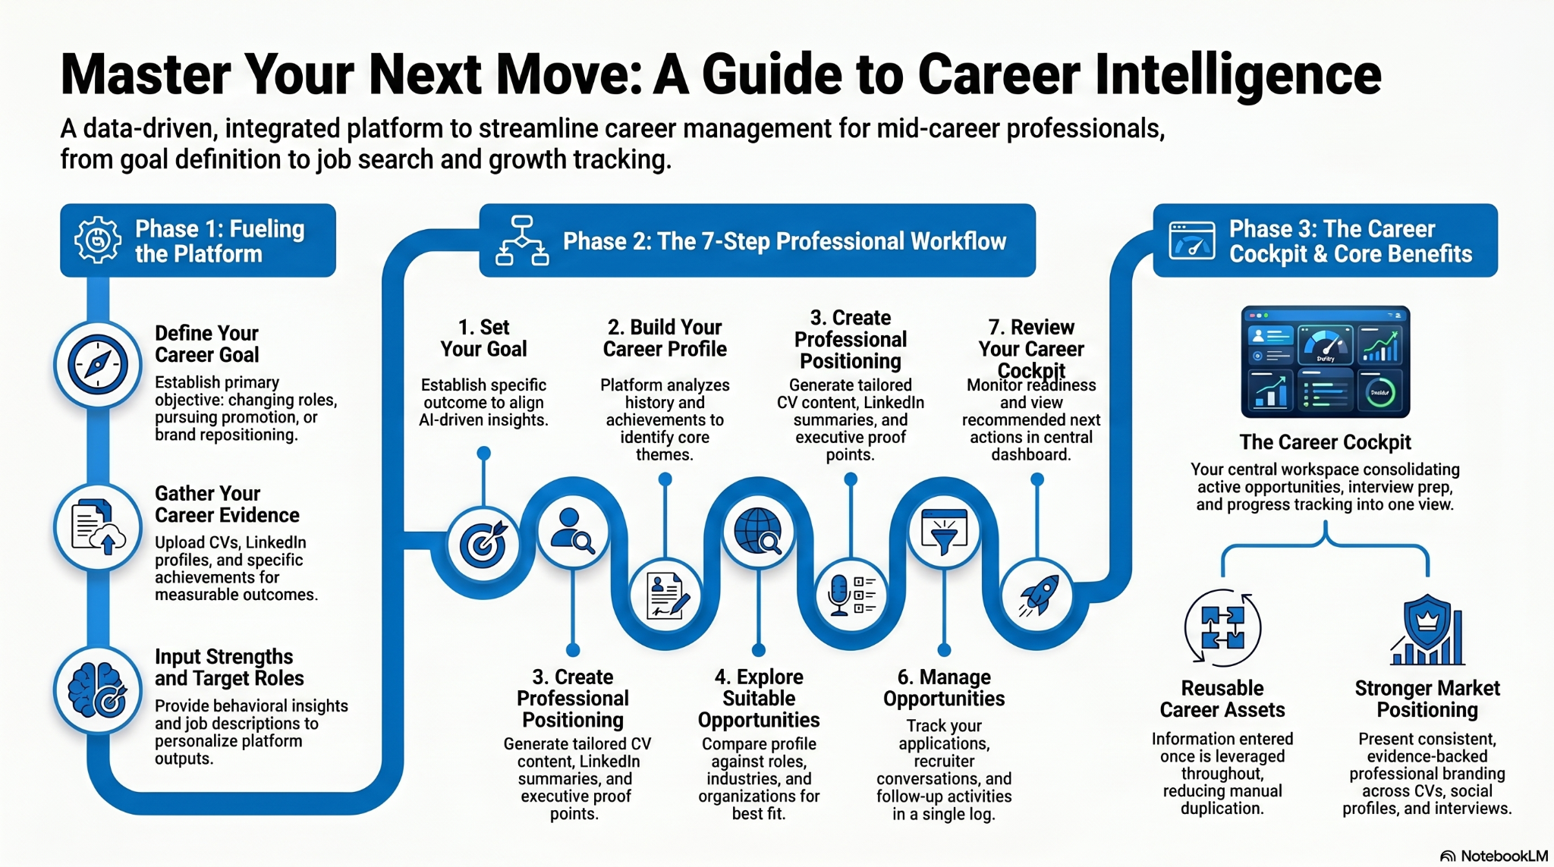

Executive Summary
Career success today is about more than qualifications and experience. It is about understanding yourself, recognising opportunities, making informed decisions, and taking action. Career Intelligence combines career insights, professional positioning, opportunity evaluation, interview preparation, and career management into one connected approach.

Why Careers Have Changed
Career paths are less predictable than they once were. Skills evolve faster, industries change rapidly, and opportunities increasingly emerge across functions, organisations, and sectors. Professionals need a better way to navigate change, evaluate options, and maintain momentum throughout their careers.

What is Career Intelligence?
Career Intelligence is the ability to understand yourself, recognise opportunities, communicate your value effectively, make informed career decisions, and take action with confidence. It combines self-awareness, market awareness, professional positioning, and practical execution.

The Five Building Blocks of Career Intelligence
1. Career Clarity – Know where you are and where you want to go.
2. Career Confidence – Back yourself and your ability to succeed.
3. Opportunity Awareness – Spot opportunities that align with your goals and experience.
4. Career Positioning – Tell your story clearly and credibly.
5. Career Mobility – Turn plans into progress through action.

The Career Intelligence Workflow
Set Your Goal → Build Your Profile → Create Your Positioning → Explore Opportunities → Prepare for Interviews → Manage Opportunities → Review Your Career Cockpit.
Each step builds on the previous one, creating a connected career-management process.

Build Your Professional Foundation
Start with your goals, strengths, experience, achievements, and career evidence. Upload your CV, LinkedIn profile, projects, leadership examples, and measurable outcomes. This creates the foundation for recommendations and future career activities.

Understand Your Professional Value
Career Intelligence helps identify recurring strengths, transferable skills, achievement patterns, leadership capabilities, and areas of expertise. The result is a clearer understanding of your professional value and how it can be applied in different contexts.

Present Yourself Effectively
Use evidence from your own experience to create stronger CVs, LinkedIn profiles, executive summaries, networking messages, and interview responses. The goal is authentic positioning, not generic self-promotion.

Explore Opportunities with Confidence
Evaluate opportunities against your goals, strengths, experience, and aspirations. Understand role fit, identify alternative pathways, and focus on opportunities that are genuinely worth pursuing.

Prepare for Career Conversations
Prepare for interviews, recruiter discussions, networking meetings, internal mobility conversations, and promotion discussions using evidence-based examples and career stories.

Manage Progress and Momentum
Track applications, interviews, recruiter interactions, networking activity, and follow-up actions. Maintain visibility of progress and keep opportunities moving forward.

The Career Cockpit
The Career Cockpit is your central workspace. It brings together your profile, opportunities, career assets, preparation resources, activity tracking, and recommended next actions in one place.

AI as Your Career Co‑Pilot
AI can help identify patterns, surface opportunities, highlight transferable skills, analyse role requirements, and support preparation. It enhances decision-making but does not replace personal judgement. You remain in control of every career decision.

Real Career Journeys
Career Changer: Reposition existing experience for a new industry.
Internal Promotion: Demonstrate readiness for greater responsibility.
Executive Repositioning: Refresh market positioning and leadership narrative.
Active Job Search: Manage opportunities, interviews, and follow-ups.
Returning to Work: Rebuild confidence and reconnect with opportunities.

Benefits of Career Intelligence
Better Clarity
Better Decisions
Stronger Positioning
Improved Interview Readiness
Better Opportunities
More Effective Career Conversations
Greater Career Momentum

The Career Intelligence Mindset
Careers are no longer built through a series of isolated events. They are built through thousands of decisions, conversations, opportunities, and actions over time.
Career Intelligence helps you make those decisions with greater clarity, confidence, and purpose.

